This tutorial will show you how to use SPSS version 12.0 to perform exploratory data analysis and descriptive statistics. You will use SPSS to create histograms, frequency distributions, stem and leaf plots, Tukey box plots, calculate the standard measures of central tendency (mean, median, and mode), calculate the standard measures of dispersion (range, semi-interquartile range, and standard deviation / variance), and calculate measures of kurtosis and skewness. This tutorial assumes that you have:

* Downloaded the standard class [data set](http://academic.udayton.edu/gregelvers/psy216/spss/216data.sav) (click on the link and save the data file)
* Started SPSS (click on Start | Programs | SPSS for Windows | SPSS 12.0 for Windows)
* Loaded the standard data set

The Frequency Command

The frequencies command can be used to determine quartiles, percentiles, measures of central tendency (mean, median, and mode), measures of dispersion (range, standard deviation, variance, minimum and maximum), measures of kurtosis and skewness, and create histograms. The command is found at Analyze | Descriptive Statistics | Frequencies (this is shorthand for clicking on the Analyze menu item at the top of the window, and then clicking on Descriptive Statistics from the drop down menu, and Frequencies from the pop up menu.):  
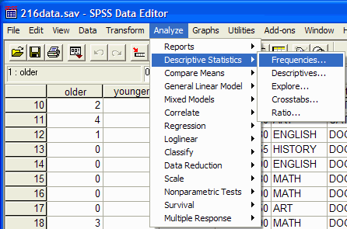

The frequencies dialog box will appear:  
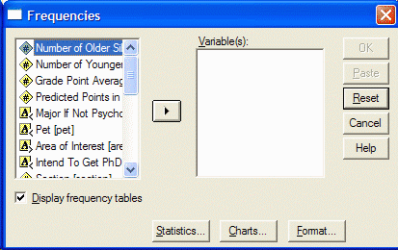

Select the variable(s) that you want to analyze by clicking on it in the left hand pane of the frequencies dialog box. Then click on the arrow button to move the variable into the Variables pane:  
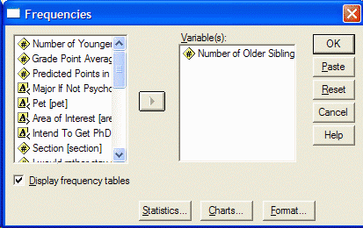

Be sure to select "Display frequency tables" if you want a frequency distribution. Specify which statistics you want to perform by clicking on the Statistics button. The Statistics dialog box will appear:  
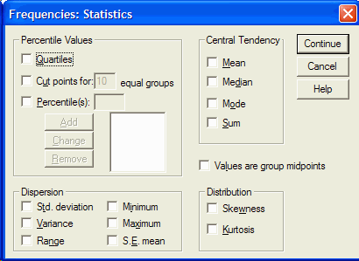

From the statistics dialog box, click on the desired statistics that you want to perform. To calculate a given percentile, click in the box to the left of percentile(s). Type in the desired percentile and click on the Add button. When you have selected all the desired statistics (e.g. mean, median, mode, standard deviation, variance, ragne, etc.), click on the Continue button.

Specify which chart you want to display by clicking on the Chart button. The chart dialog box will appear:  
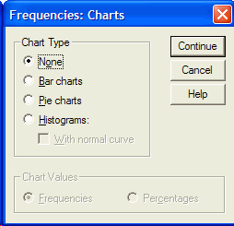

Click on the desired chart (usually Histogram) and click on the Continue button.  
Click on OK in the frequencies dialog box. The SPSS Output Viewer will appear.

In the SPSS Output Viewer, you will see the requested statistics and chart. This is what the Statistics output looks like. It lists the requested measures of central tendency, measures of dispersion, measures of skewness and kurtosis, and the quartiles and percentiles.

|  |  |
| --- | --- |
| http://academic.udayton.edu/gregelvers/psy216/spss/images/freq_out_stats.gif | The output has two columns. The left column names the statistic and the right column gives the value of the statistic. For example, the mean of this data is 1.26 (since your data set may be different, you may get a different value.) The skewness measure is greater than 0 when the distribution is skewed. The kurtosis measure is 0 for a normal distribution. Positive values imply a leptokurtic distribution, while negative values imply a platykurtic distribution. |

If you scroll down, you will see the frequency distributions.  
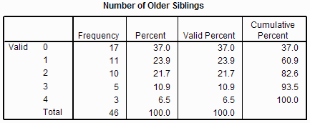

If you scroll down, you will see the histogram (or whatever chart you requested.)  
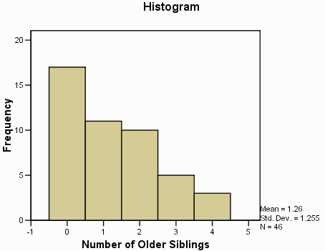

The Descriptives Command

The descriptives command can be used to determine measures of central tendency (mean), measures of dispersion (range, standard deviation, variance, minimum and maximum), and measures of kurtosis and skewness. The command is found at Analyze | Descriptive Statistics | Descriptives (this is shorthand for clicking on the Analyze menu item at the top of the window, and then clicking on Descriptive Statistics from the drop down menu, and Descriptives from the pop up menu.):  
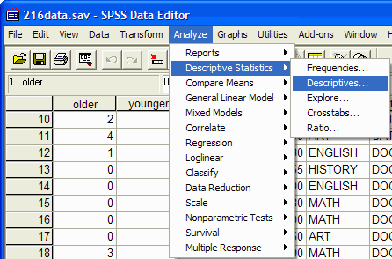

The descriptives dialog box will appear:  
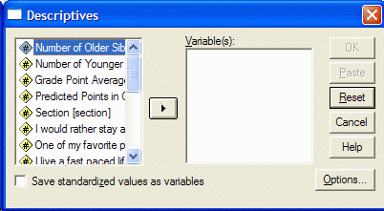

Select the variable(s) that you want to analyze by clicking on it in the left hand pane of the descriptives dialog box. Then click on the arrow button to move the variable into the Variables pane:  
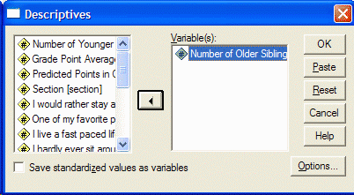

Specify which statistics you want to perform by clicking on the Options button. The Options dialog box will appear:  
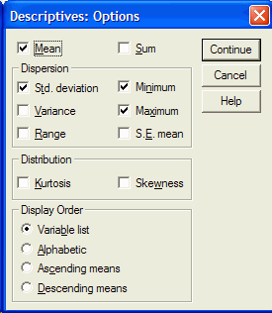

Select the statistics that you want by clicking on them (e.g. mean, standard deviation, variance, range, minimum, etc.). Then click on the Continue button. Click on the OK button in the Descriptives dialog box. The SPSS Output Viewer will appear with your results in it. The following is an example of the output:  
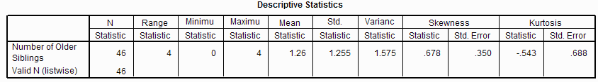

The output gives the values of the requested statistics.

The Explore Command

The explore command can be used to determine measures of central tendency (mean and median), measures of dispersion (range, interquartile range, standard deviation, variance, minimum and maximum), measures of kurtosis and skewness, and prepare histograms, stem and leaf plots, and Tukey box plots. The command is found at Analyze | Descriptive Statistics | Explore:  
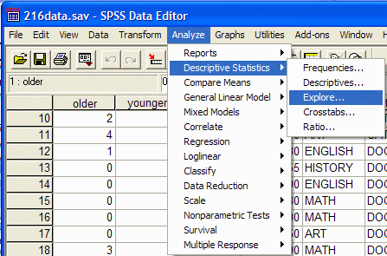

The explore dialog box will appear:  
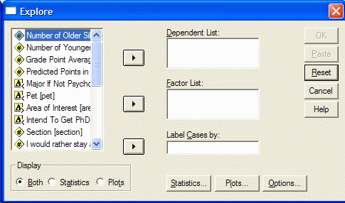

Select the variable(s) that you want to analyze by clicking on it in the left hand pane of the explore dialog box. Then click on the top arrow button to move the variable into the Dependent List:  
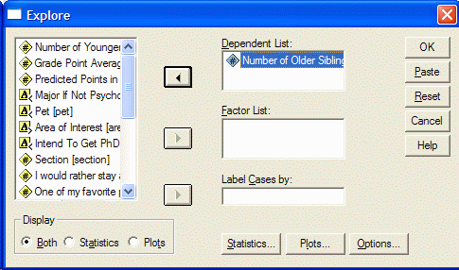

Specify which plots you want to prepare by clicking on the Plots button. The Plots dialog box will appear:  
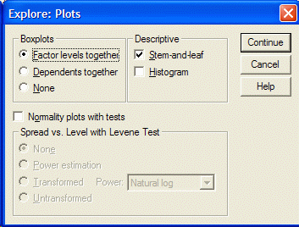

Select the plots that you want by clicking on them (e.g. Stem-and-leaf and histogram). Then click on the Continue button. Click on the OK button in the Explore dialog box. The SPSS Output Viewer will appear with your results in it. The following is an example of the output for the descriptive statistics:  
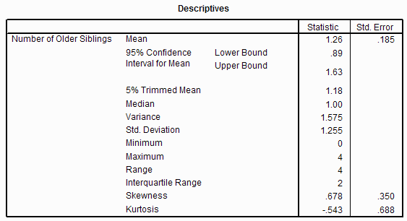

The output gives the values of the requested statistics. If you scroll down, you will see the requested plots:  
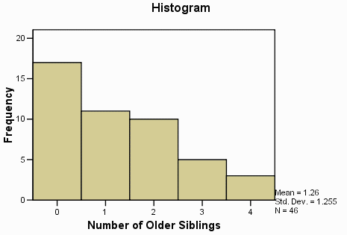  
  
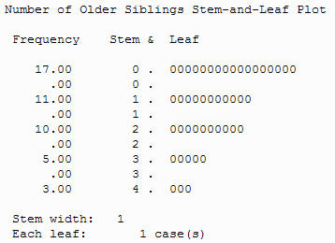

|  |  |
| --- | --- |
| http://academic.udayton.edu/gregelvers/psy216/spss/images/explore_out_tbox.gif | The Tukey box plot shows the first (bottom of box) and third (top of box) quartiles (equivalently the 25th and 75th percentiles), the median (the horizontal line in the box), the range (excluding outliers and extreme scores) (the "whiskers" or lines that extend from the box show the range), outliers (a circle represents each outlier -- the number next to the outlier is the observation number.) An outlier is defined as a score that is between 1.5 and 3 box lengths away from the upper or lower edge of the box (remember the box represents the middle 50 percent of the scores). An extreme score is defined as a score that is greater than 3 box lengths away from the upper or lower edge of the box. |